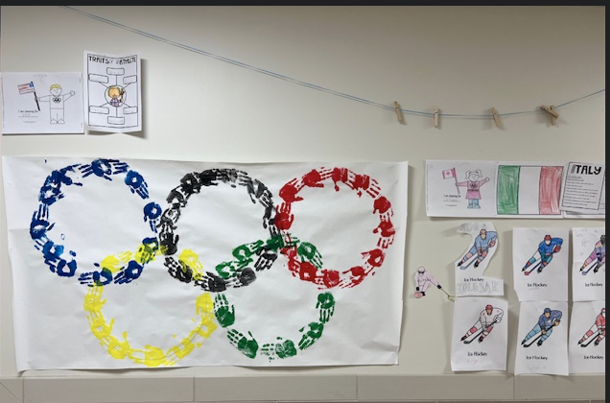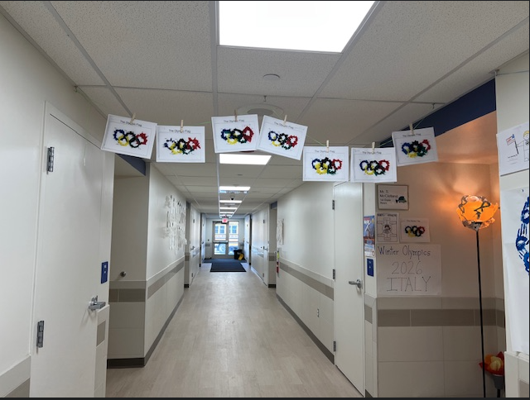
Pictures from our Celebrate the 2026 Winter Olympic Games unit. We learned about the different types of events through reading and writing activities. Students learned about Italy, its landscape, and some of the country's history. We participated in different events to learn about teamwork and sportsmanship.

