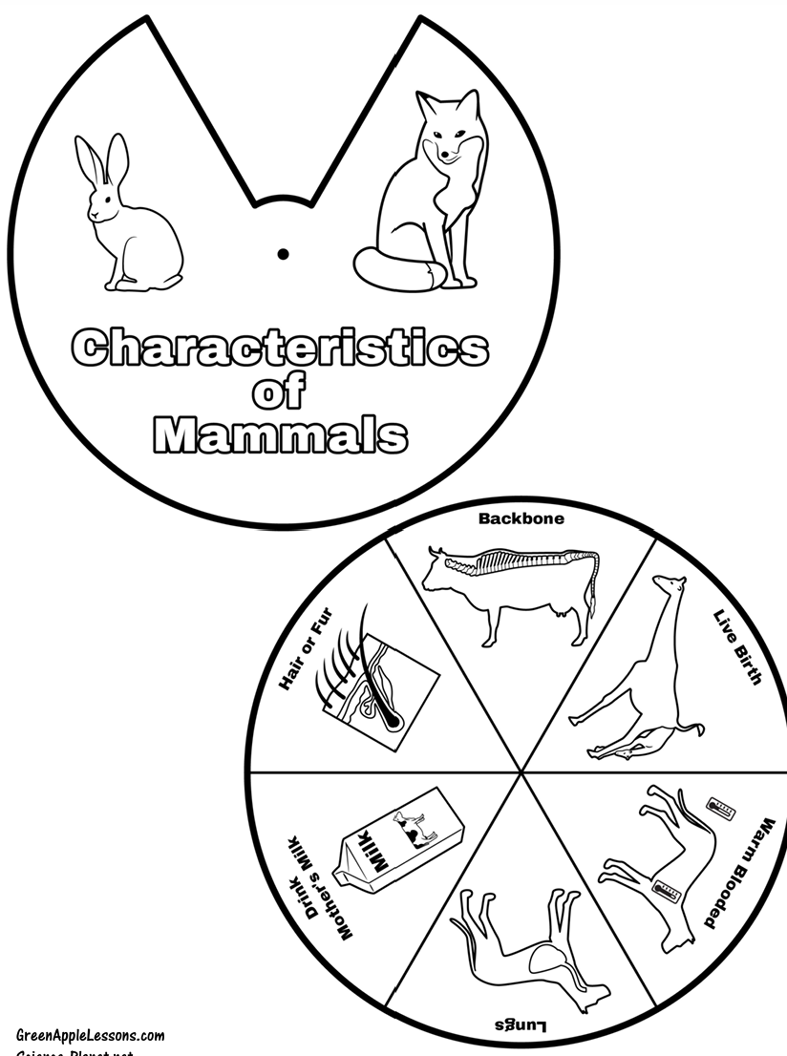
This activity went with the Science Unit I taught. This was used for the day we talked about mammals. After the lesson, the students cut and put together this story wheel. We can use these types of activities to quickly assess what the students learned by having them retell. In this case, the students would retell what they learned about the characteristics of a Mammal as they turn the wheel to each picture.

