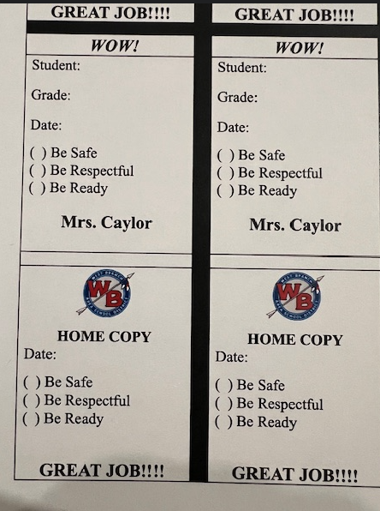
WOW cards are part of our school-wide PBIS system, which encourages students to be safe, be respectful, and be ready.
Students receive a WOW card when they exhibit behaviors such as walking quietly, helping a friend, being ready to learn, helping in the cafeteria, and being respectful on the bus.
When students receive a WOW card, they can turn it in for a chance to be pulled and win some super cool prizes.
I am proud to say I have been a member of our Tier 1 team for the past two years. I have helped plan end-of-the-year rewards and have input on the infraction and WOW card systems.
Here is a post from Principal Nunley about the PBIS WOW card basket that I put together and donated for April's giveaway.

