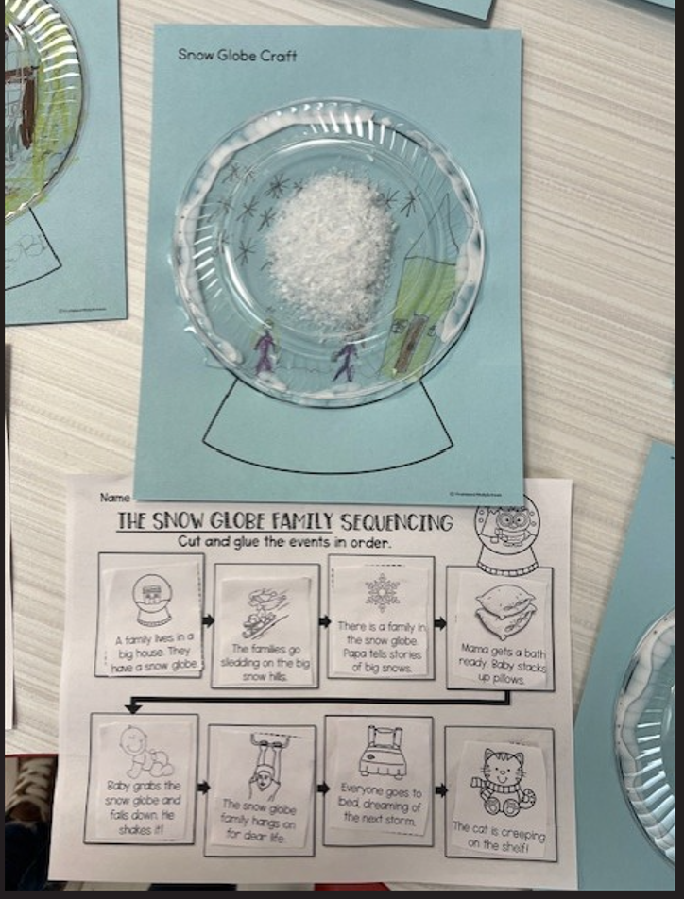
The picture above shows the sequencing worksheet the students completed after I did a shared reading of the book The Snow Globe Family. After we, the students, made our own snow globe by drawing a picture of our family playing in the snow. We used fake glitter snow and a clear plastic plate to complete their snow globe.

