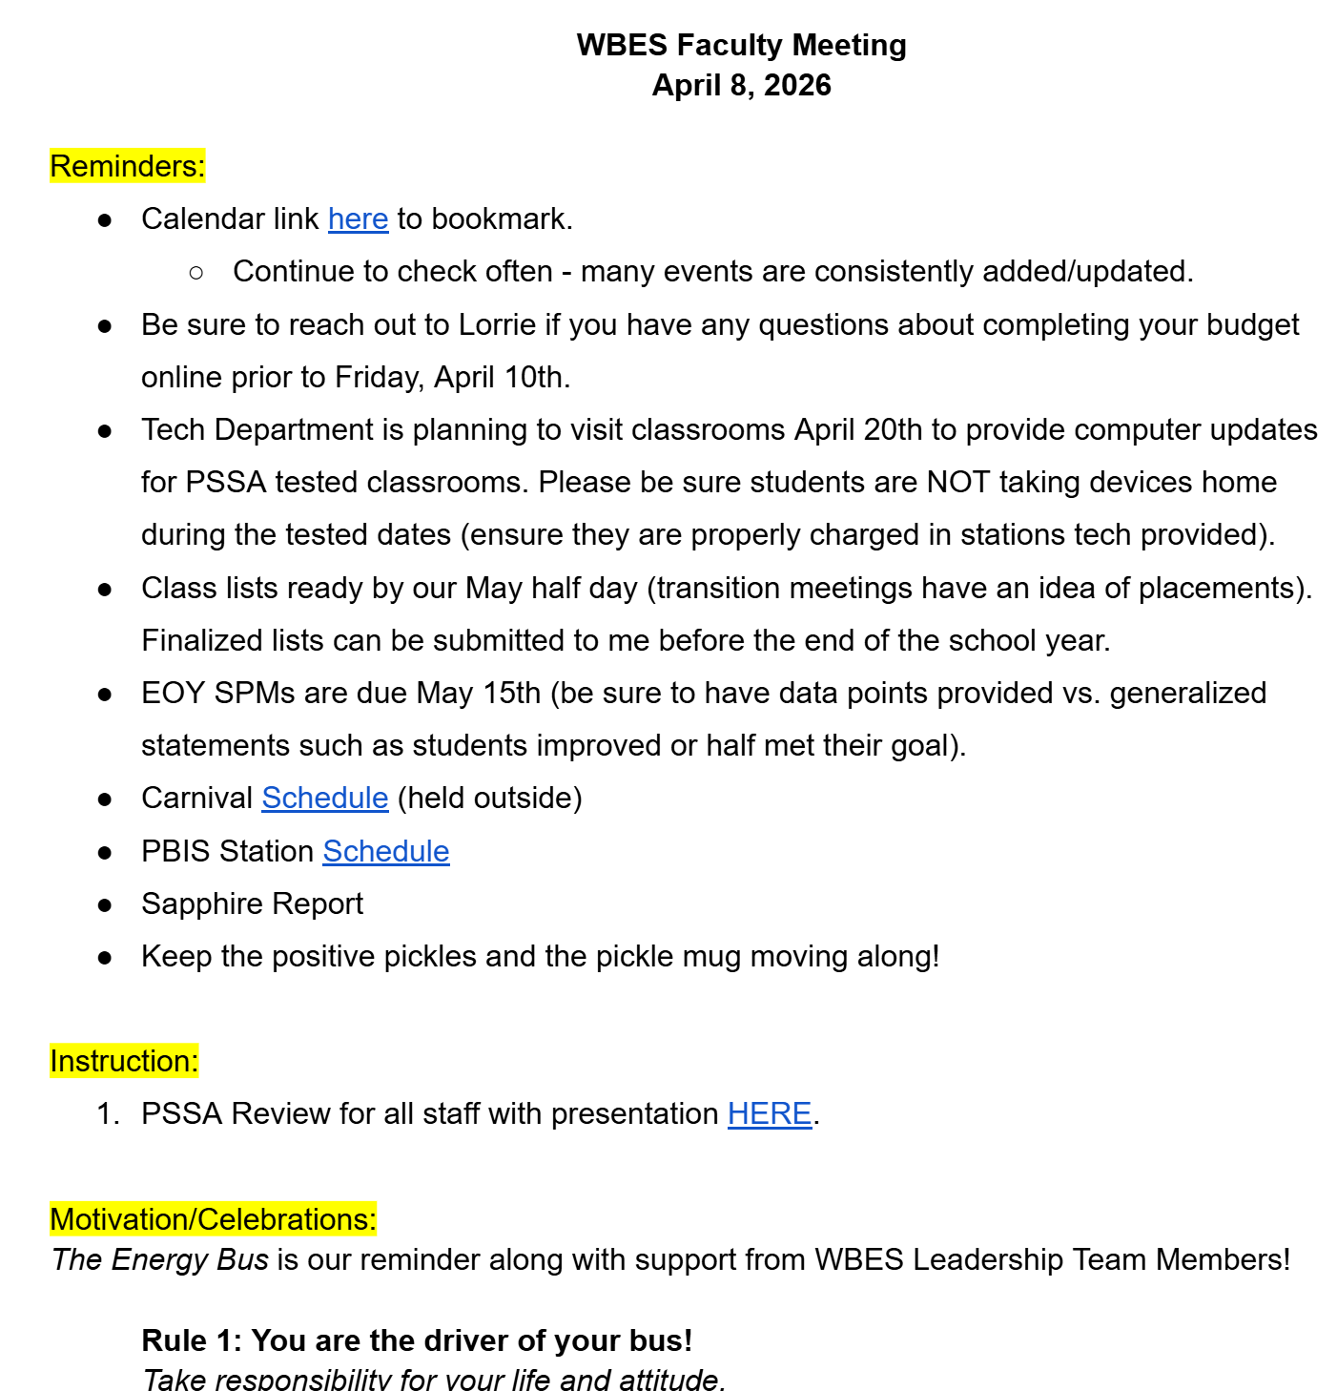
Above is a sample of our faculty meeting agenda. While student teaching, I attended several faculty meetings, in-service training sessions, and half-day PD sessions. These days were spent doing trainings, going over important updates, and working with my first-grade team to plan and prepare for upcoming units in science and math

