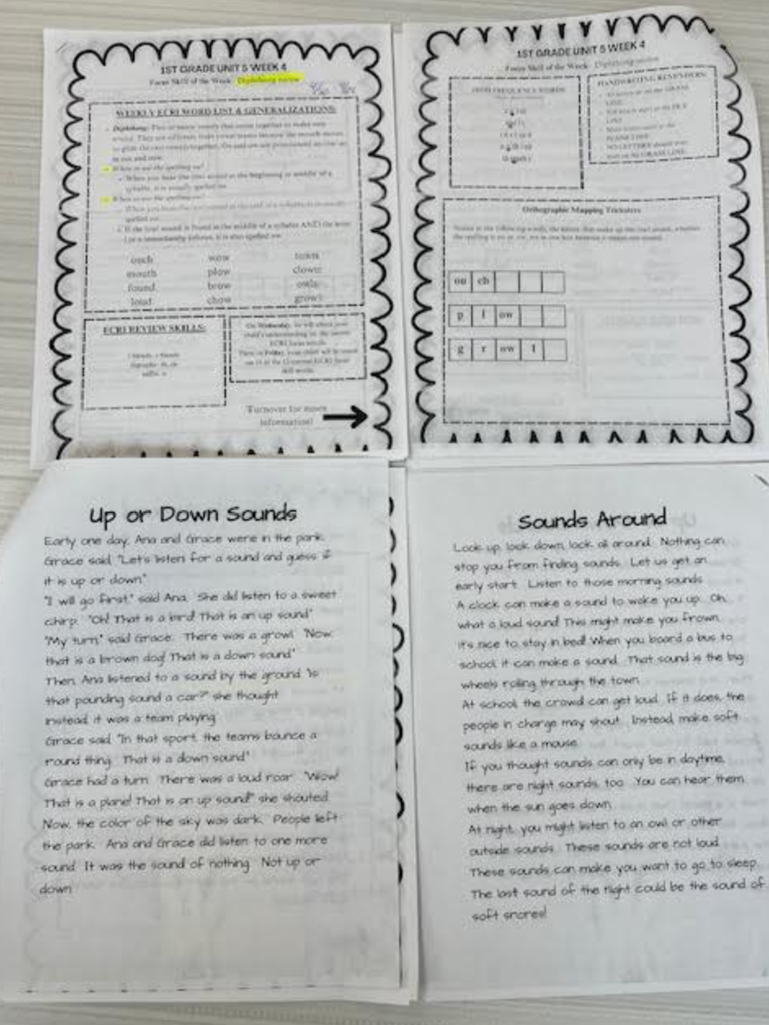
Enhanced Core Reading Instruction (ECRI)
Above is a sample of our ECRI unit packets, which each student receives at the beginning of a new week for their reading folders. These packets align with the ECRI unit we are teaching that week, and students take their folders home each night to practice and read our current skills and passages.
I was fortunate enough to be ECRI trained 3 years ago. I see the value in this curriculum and feel comfortable and confident teaching it at the kindergarten, first, and second grade levels.

