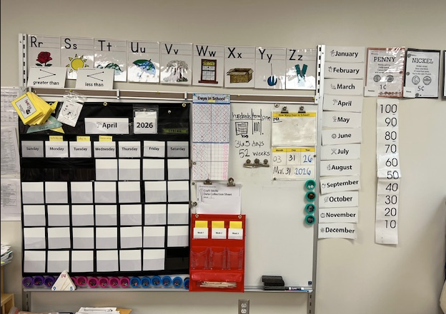
This photo shows our number corner and calendar space. Our school uses the Bridges Math curriculum, and this routine is part of the program. I helped set up and change this space while I was student teaching. This routine, which is taught in a 20–25-minute time frame, focuses on calendar learning: the days of the week, months, years, and seasons. Each month, the calendar has a special focus through the Bridges curriculum. The students also do a day-in-school countdown and learn about place value, money, and time during this routine. This helps evaluate and build on the math skills taught during their math lessons.

