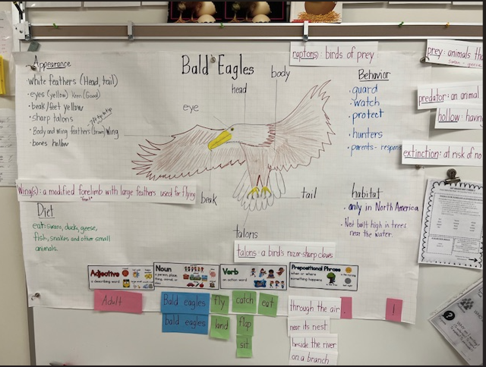
Above is a picture of a pictorial chart we made of our Bald Eagle unit. As a class, we read a book, watched videos, and researched facts about Bald Eagles. We then categorized these facts and wrote about what we learned.

