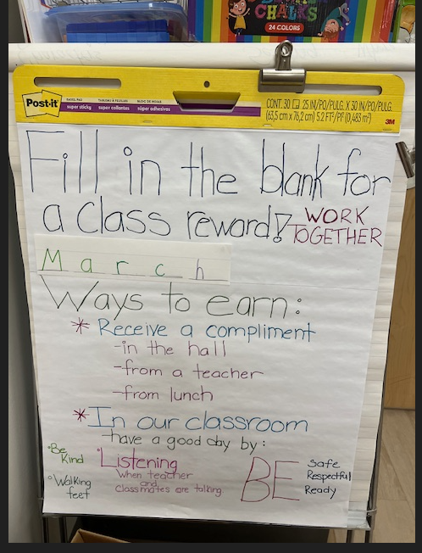
A classroom management system is implemented to encourage students to maintain positive behaviors and meet expectations.
This system mimics what students will be expected to do in second grade.

