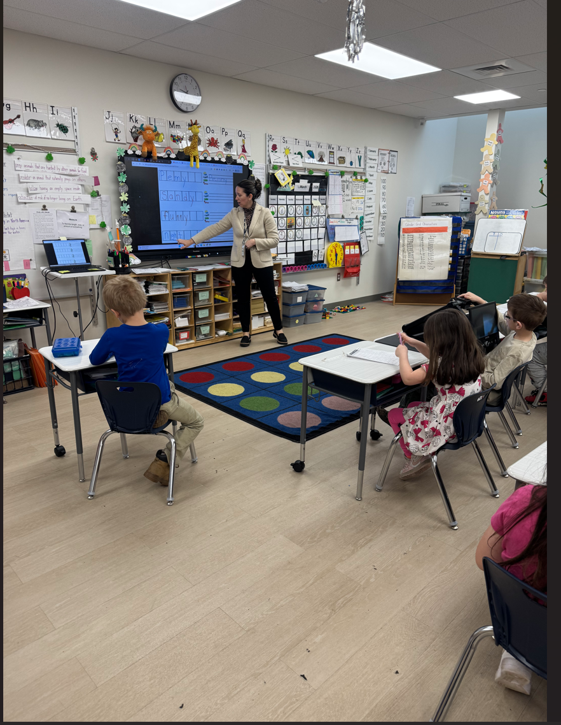
Above is a photo of me teaching and communicating with my first-grade students. In this photo, I am teaching the ECRI dictation routine. This routine requires strong listening and communication skills to help students sound out and spell words correctly.

